Practical 4

Part A:
Aim:
1. Password strength (PasswordChecker.java + Driver.java)
(a) In PasswordChecker, check four rules — length ≥ 8, contains an uppercase letter,
contains a digit, contains a special character — using regex (e.g. “.*[A-Z].*”) or
String methods.
(b) Write strength(String pw) that counts how many rules pass and returns “Weak” (0–
1), “Medium” (2–3) or “Strong” (4).
(c) In Driver.main: test several passwords; for each, print which rules passed and the
final label.
Expected output: “abc” → Weak; “Abcd1234!” → Strong.

Code:
PasswordChecker.java
public class PasswordChecker {

// Check whether password length is at least 8
public static boolean hasMinimumLength(String pw) {
return pw.length() >= 8;
}

// Check whether password contains an uppercase letter
public static boolean hasUppercase(String pw) {
return pw.matches(".*[A-Z].*");
}

// Check whether password contains a digit
public static boolean hasDigit(String pw) {
return pw.matches(".*[0-9].*");
}

// Check whether password contains a special character
public static boolean hasSpecialCharacter(String pw) {
return pw.matches(".*[^a-zA-Z0-9].*");
}

// Calculate password strength
public static String strength(String pw) {

int count = 0;

if (hasMinimumLength(pw)) {
count++;
}

if (hasUppercase(pw)) {
count++;
}

if (hasDigit(pw)) {
count++;
}

if (hasSpecialCharacter(pw)) {
count++;
}

if (count <= 1) {
return "Weak";
} else if (count <= 3) {
return "Medium";
} else {
return "Strong";
}
}
}

Driver.java
public class Driver {

public static void main(String[] args) {

String[] passwords = {
"abc",
"abcdefgh",
"Abcdefgh",
"abcd1234",
"Abcd1234!",
"Password1"
};

for (String password : passwords) {

System.out.println("Password: " + password);

System.out.println(
"Length >= 8: "
+ PasswordChecker.hasMinimumLength(password)
);

System.out.println(
"Uppercase: "
+ PasswordChecker.hasUppercase(password)
);

System.out.println(
"Digit: "
+ PasswordChecker.hasDigit(password)
);

System.out.println(
"Special Character: "
+ PasswordChecker.hasSpecialCharacter(password)
);

System.out.println(
"Strength: "
+ PasswordChecker.strength(password)
);

System.out.println("-----------------------------");
}
}
}

Output
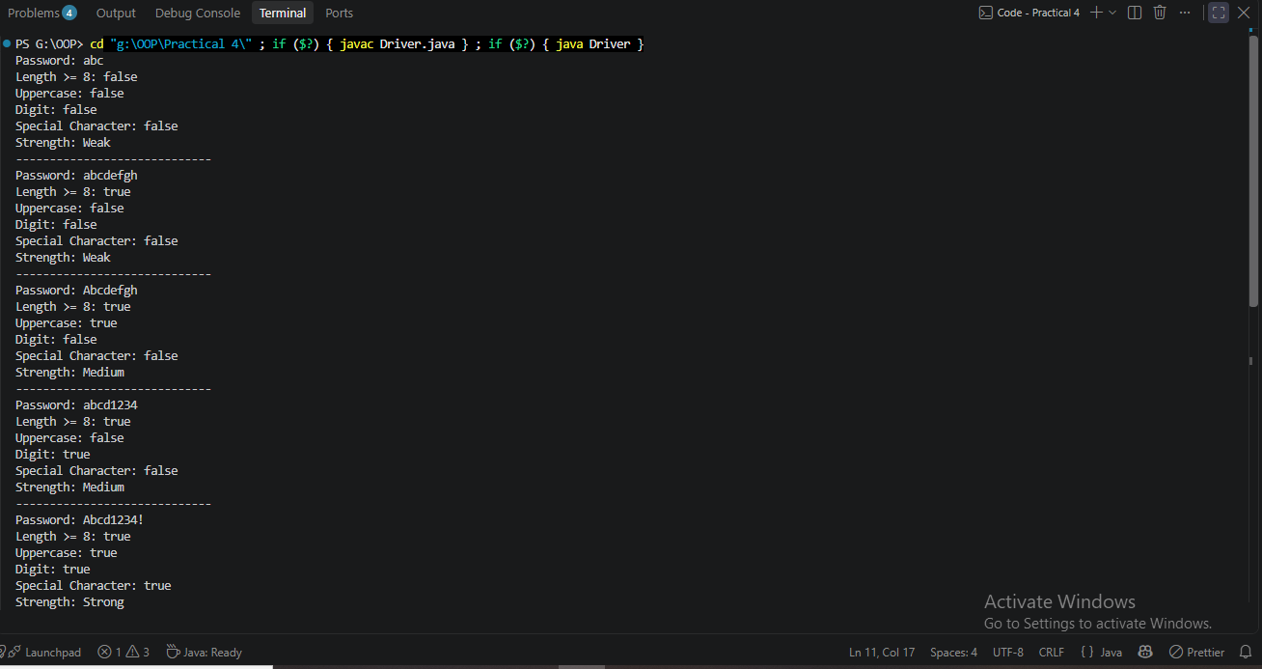

2. Chat-log filter (ChatFilter.java + Driver.java)
(a) In Driver.main, define a String[] of log lines like “10:05 alice Hello there” (include one malformed line with fewer than 3 parts).
(b) Read a keyword from the user.
(c) For each line, split into time/user/message with split(“ ”, 3); skip lines that do not have 3 parts.
(d) If the message contains the keyword (case-insensitive), increment a counter and append “time user: message” to a StringBuilder.
(e) Print “Matches: N” and the built report.
Expected output: keyword “hello” over 3 lines (1 malformed) → “Matches: 1” and the matching line.

Code:
ChatFilter.java
public class ChatFilter {

public static boolean containsKeyword(String message, String keyword) {
return message.toLowerCase().contains(keyword.toLowerCase());
}

public static String formatLine(String time, String user, String message) {
return time + " " + user + ": " + message;
}
}

Driver.java
import java.util.Scanner;

public class Drive2{

public static void main(String[] args) {

Scanner sc = new Scanner(System.in);

// Chat log lines
String[] logs = {
"10:05 alice Hello there",
"10:10 bob How are you?",
"10:15 Charlie" // Malformed line
};

// Read keyword
System.out.print("Enter keyword: ");
String keyword = sc.nextLine();

int matches = 0;

// StringBuilder for the final report
StringBuilder report = new StringBuilder();

// Process each log line
for (String line : logs) {

// Split into maximum 3 parts:
// time, user, message
String[] parts = line.split(" ", 3);

// Skip malformed lines
if (parts.length < 3) {
continue;
}

String time = parts[0];
String user = parts[1];
String message = parts[2];

// Check whether message contains keyword
if (ChatFilter.containsKeyword(message, keyword)) {

matches++;

report.append(
ChatFilter.formatLine(time, user, message)
);

report.append("\n");
}
}

// Print result
System.out.println("Matches: " + matches);

if (matches > 0) {
System.out.println(report);
}

sc.close();
}
}

Output
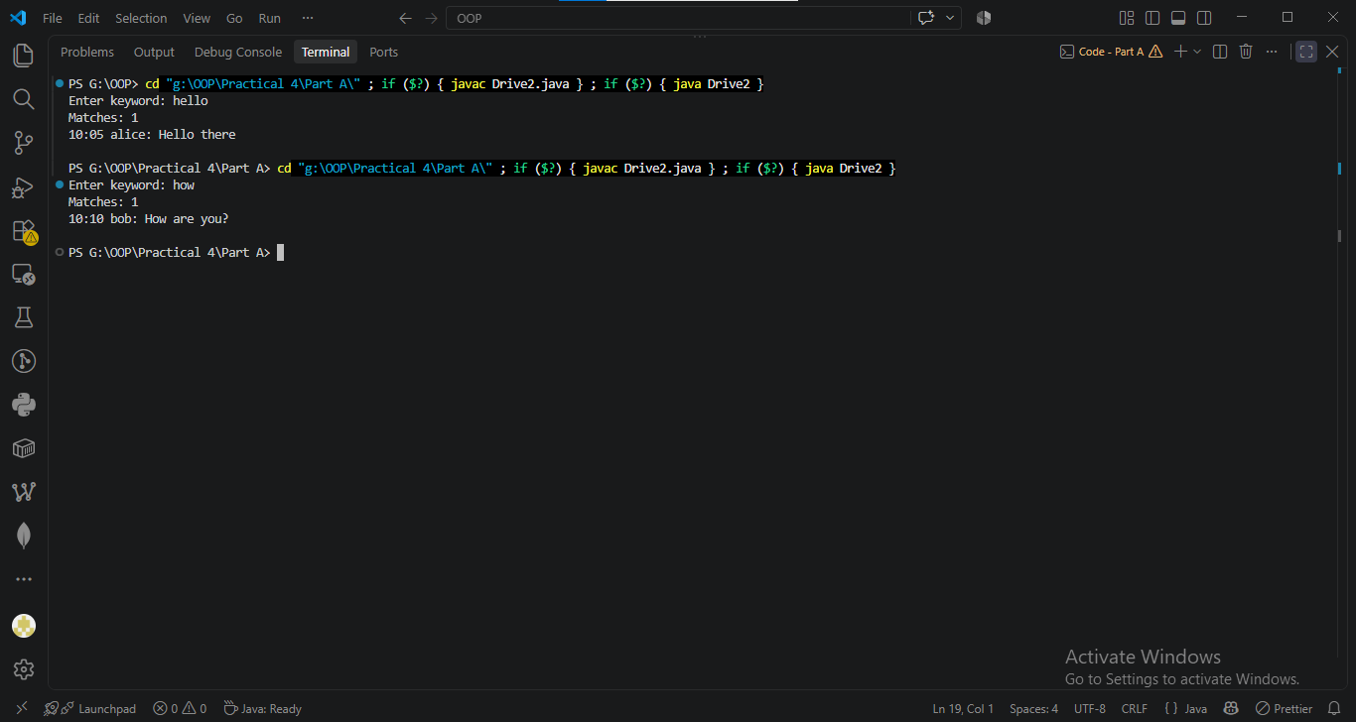

3. (For Advanced Learners – home) Template filler (TemplateFiller.java + Driver.java)
(a) In Driver.main, define a template like “Dear {name}, order {id} ships {date}.” And two parallel arrays: names {“name”, “id”} and values {“Riya”, “A07”} (note {date} is not supplied).
(b) Compile a Pattern for \{(\w+)\} and get a Matcher on the template.
(c) Walk the matches with a StringBuilder: for each {placeholder}, look up its value in the names array and replace with the value, or with “[?]” if not found.
(d) Print the filled template.
Expected output: the unsupplied {date} becomes [?].

Code:
TemplateFiller.java
import java.util.regex.Matcher;
import java.util.regex.Pattern;

public class TemplateFiller {

public static String fillTemplate(
String template,
String[] names,
String[] values) {

// Pattern for placeholders like {name}, {id}, {date}
Pattern pattern = Pattern.compile("\\{(\\w+)\\}");

Matcher matcher = pattern.matcher(template);

StringBuilder result = new StringBuilder();

int lastEnd = 0;

while (matcher.find()) {

// Add text before the current placeholder
result.append(template, lastEnd, matcher.start());

// Get placeholder name without { }
String placeholder = matcher.group(1);

String replacement = "[?]";

// Search for placeholder in names array
for (int i = 0; i < names.length; i++) {
if (names[i].equals(placeholder)) {
replacement = values[i];
break;
}
}

// Add replacement
result.append(replacement);

lastEnd = matcher.end();
}

// Add remaining text after the last placeholder
result.append(template, lastEnd, template.length());

return result.toString();
}
}

Driver.java
public class Driver1 {

public static void main(String[] args) {

String template =
"Dear {name}, order {id} ships {date}.";

String[] names = {
"name",
"id"
};

String[] values = {
"Riya",
"A07"
};

String result = TemplateFiller.fillTemplate(
template,
names,
values
);

System.out.println(result);
}
}

Output
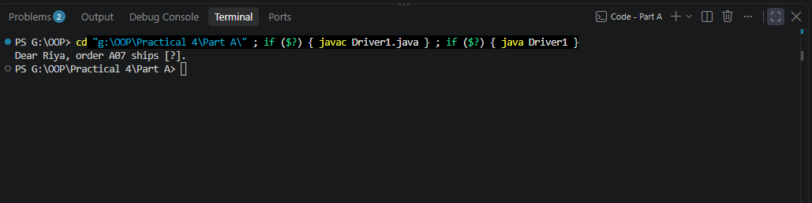

Key Questions / Analysis / Interpretation to be evaluated during/after Implementation
- What is the difference between String, StringBuilder and StringBuffer, and when is each preferred?

Ans.
Type | Mutable? | Thread-safe? | Preferred when
String | ❌ No | Yes, because immutable | Text that doesn't change
StringBuilder | ✅ Yes | ❌ No | Frequently modifying/combining text in a single thread
StringBuffer | ✅ Yes | ✅ Yes | Frequently modifying text where multiple threads may access it

String
String is immutable, meaning its contents cannot be changed after creation.
String name = "Rahul";
name = name + " Patel";
The original "Rahul" String isn't modified; a new String is created.
Use String for normal text:
String accountNumber = "AC0001";

StringBuilder
StringBuilder is mutable, so it can modify the same object without creating a new String for every operation.
StringBuilder statement = new StringBuilder();

statement.append("Account: AC0001\n");
statement.append("Balance: Rs.5000\n");
This is particularly useful for your StatementFormatter, where you're constructing a multi-line statement.
For normal single-threaded programs, StringBuilder is generally preferred over StringBuffer for repeated text modifications.

StringBuffer
StringBuffer is also mutable, but its methods are synchronized, making it suitable when the same buffer needs to be safely accessed by multiple threads.
StringBuffer buffer = new StringBuffer();

buffer.append("Hello");
buffer.append(" World");
The synchronization adds overhead, so you normally don't choose it unless thread safety is actually required.

- What does the regular expression [6-9][0-9]{9} match, and why use anchors?

Ans.
The expression:
[6-9][0-9]{9}
matches a sequence consisting of:
- one digit from 6 to 9
- followed by exactly 9 digits from 0 to 9
So it represents a 10-digit number starting with 6, 7, 8, or 9.

Example
9876543210
Breakdown:
9 → [6-9]
876543210 → [0-9]{9}
So it matches.
Another valid example:
8123456789

Why use anchors?
In your validator, we used:
^[6-9][0-9]{9}$
The anchors are:
^
means start of the input
and:
$
means end of the input.
Therefore:
^[6-9][0-9]{9}$
requires the entire string to match the pattern.
Without anchors, a longer string could contain a matching 10-digit sequence somewhere inside it.

- Why should input be validated at the boundary before it is used?

Ans.
• Prevents invalid data from entering the system.
• Keeps the rest of the program simpler because it can rely on validated data.
• Reduces unexpected errors.
• Improves data consistency.
• Provides a clear place for input validation.
• Helps protect applications from malformed or malicious input.

